Ideation Phase

Define the problem statements

|  |  |
| --- | --- |
| Date | 17 September 2022 |
| Team ID | PNT2022TMID24244 |
| Project Name | Smart Farmer-IOT Enabled Smart Farming Application |
| Maximum Marks | 2 Marks |

**Customer Problem Statement Template**

Create a problem statement to understand your customer's point of view. The Customer Problem Statement template helps you focus on what matters to create experiences people will love.

A well-articulated customer problem statement allows you and your team to find the ideal solution for the challenges your customers face. Throughout the process, you’ll also be able to empathize with your customers, which helps you better understand how they perceive your product or service.

**Reference:**

https://micro.com/app/board/uXjVPRGMeak=/

**Example**

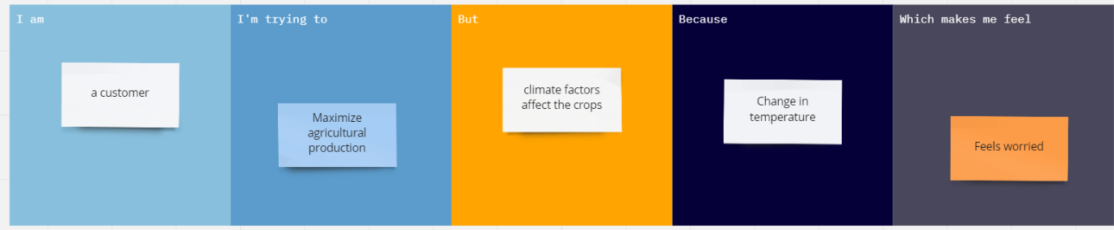

|  |  |  |  |  |  |
| --- | --- | --- | --- | --- | --- |
| Problem statement (ps) | I am (customer) | I’m Trying to | But | Because | Which makes me feel |
| PS-1 | Customer-1 | Increase the production of crops | Pesticides affects the crop Production | Pesticides are formulated to kill pests | sad |
| PS-2 | Customer-2 | Double the growth of crops | Soil fertility declines | Inadequate use of fertilizers and soil erosion | worried |
| PS-3 | Customer-3 | Soil PH Level Monitoring | It affects the mineral content and texture of the soil | It develops the strongly acidic soil can lead to poor growth of crops | Bad |